Module – Website Designing – HTML5

- Create this using video tag.
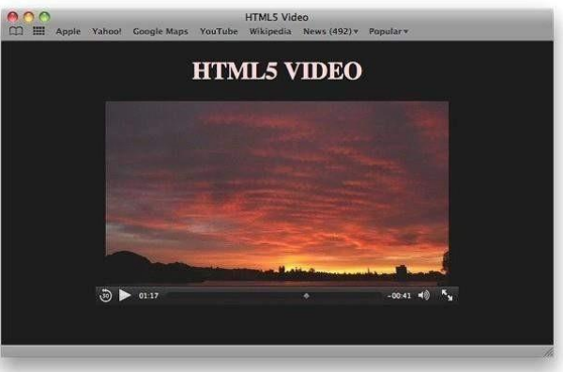
- Create some audio file like this in html 5.


- create some shape using canvas tag in html.
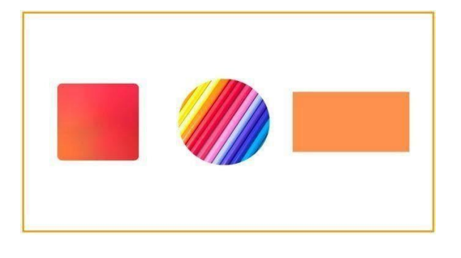

- create some shape using svg tag in html.
